ANALYTICAL PROBLEM SOLVING

Name: ADHITHYA.S

Register Number: 192412352

Course Code: ITA0606

Course Name: MACHINE LEARNING

1. Perceptron — Pass/Fail Classification

Given
- Weights: w₁ (study hours) = 0.6, w₂ (attendance) = 0.4
- Bias: b = −0.5
- Inputs: x₁ (study hours) = 2, x₂ (attendance) = 1

Step 1: Compute Net Input
net = w₁x₁ + w₂x₂ + b = (0.6 × 2) + (0.4 × 1) + (−0.5)
net = 1.2 + 0.4 − 0.5 = 1.1

Step 2: Apply Step Activation Function
f(net) = 1, if net ≥ 0; f(net) = 0, if net < 0
Since net = 1.1 ≥ 0 ⇒ f(net) = 1

Conclusion
The perceptron output is 1, so the student is classified as PASS. The combined weighted contribution of study hours and attendance is strong enough to overcome the negative bias, pushing the net input above the decision threshold of 0.

2. Single Neuron Training — Delta Rule

Given
- Initial weight: w = 0.5
- Learning rate: η = 0.1
- Input: x = 2
- Actual output: o = 0.6
- Target output: t = 1

Step 1: Compute the Error
Error = t − o = 1 − 0.6 = 0.4

Step 2: Apply the Delta (Widrow–Hoff) Rule
Δw = η × Error × x = 0.1 × 0.4 × 2 = 0.08

Step 3: Update the Weight
w_new = w_old + Δw = 0.5 + 0.08 = 0.58

Conclusion
After one iteration of training, the updated weight is 0.58. Since the neuron under-predicted the target (positive error), the weight is increased so that, on the next forward pass, the neuron's output moves closer to the target value of 1.
Note: if the neuron used a sigmoid activation, the generalized delta rule would additionally multiply by the derivative o(1−o); the calculation above uses the basic delta rule as implied by the question.

3. Confusion Matrix — Disease Prediction Model

Given
 | Predicted Positive | Predicted Negative | Total (Actual)
Actual Positive | TP = 180 | FN = 50 | 230
Actual Negative | FP = 20 | TN = 150 | 170

Total samples = 180 + 150 + 20 + 50 = 400

Calculations
Metric | Formula | Calculation | Result
Accuracy | (TP+TN)/Total | (180+150)/400 | 0.825 = 82.5%
Precision | TP/(TP+FP) | 180/200 | 0.90 = 90%
Sensitivity (Recall) | TP/(TP+FN) | 180/230 | 0.7826 = 78.26%
Specificity | TN/(TN+FP) | 150/170 | 0.8824 = 88.24%

Reliability Discussion for Medical Diagnosis
- Overall accuracy (82.5%) and precision (90%) look strong — when the model predicts "disease", it is right 90% of the time, so false alarms are relatively rare.
- However, sensitivity/recall is only 78.26%, meaning about 21.74% of actual disease cases (50 out of 230) are missed as false negatives.
- In medical diagnosis, false negatives are typically far more costly than false positives — a missed disease case can delay treatment and harm the patient, whereas a false positive usually just leads to an extra confirmatory test.
- Conclusion: the model is reasonably reliable but not yet ideal for medical deployment. Before clinical use, sensitivity should be improved — e.g., by adjusting the classification threshold, using cost-sensitive/weighted loss functions that penalize false negatives more heavily, gathering more positive-class training data, or using ensemble methods — so that fewer true disease cases go undetected.

4. Genetic Algorithm — Maximizing f(x) = x²

Step 1: Initial Population and Fitness Evaluation
Individual | Binary (4-bit) | Fitness f(x) = x²
2 | 0010 | 4
4 | 0100 | 16
6 | 0110 | 36
8 | 1000 | 64

Step 2: Selection of Best Candidates
Ranking by fitness: 8 (64) > 6 (36) > 4 (16) > 2 (4). The two fittest individuals — x = 8 and x = 6 — are selected as parents for reproduction, since a GA favors higher-fitness individuals for the mating pool (survival-of-the-fittest selection).

Step 3: Crossover (Exchanging the Least Significant Bits)
Parent A = 6 = 0 1 | 1 0 (MSBs = 01, LSBs = 10)
Parent B = 8 = 1 0 | 0 0 (MSBs = 10, LSBs = 00)
Exchanging the two least-significant bits between the parents:
- Offspring 1 = MSB(A) + LSB(B) = 01 00 = 0100 = 4 (fitness = 16)
- Offspring 2 = MSB(B) + LSB(A) = 10 10 = 1010 = 10 (fitness = 100)
Offspring 2 (x = 10) has a higher fitness (100) than either parent, illustrating how crossover can combine bit patterns from two good parents to reach an even better solution — the core mechanism by which GAs search the solution space.

Role of Mutation
- Mutation randomly flips one or more bits in an offspring's chromosome (e.g., 1010 → 1011) with a small probability.
- It introduces genetic diversity that crossover alone cannot produce, since crossover only recombines bit patterns already present in the population.
- It prevents premature convergence by helping the algorithm escape local optima — without mutation, the population can become too similar and get stuck before reaching the true maximum.
- It allows the algorithm to explore new, previously unrepresented regions of the search space, improving the overall effectiveness and robustness of the search over generations.

5. Training vs Validation Accuracy — Trend Analysis

Observed Trend
- Training accuracy rises steadily throughout: 60% → 95%.
- Validation accuracy rises initially (58% → 72%) but then falls back to 68% in later epochs.
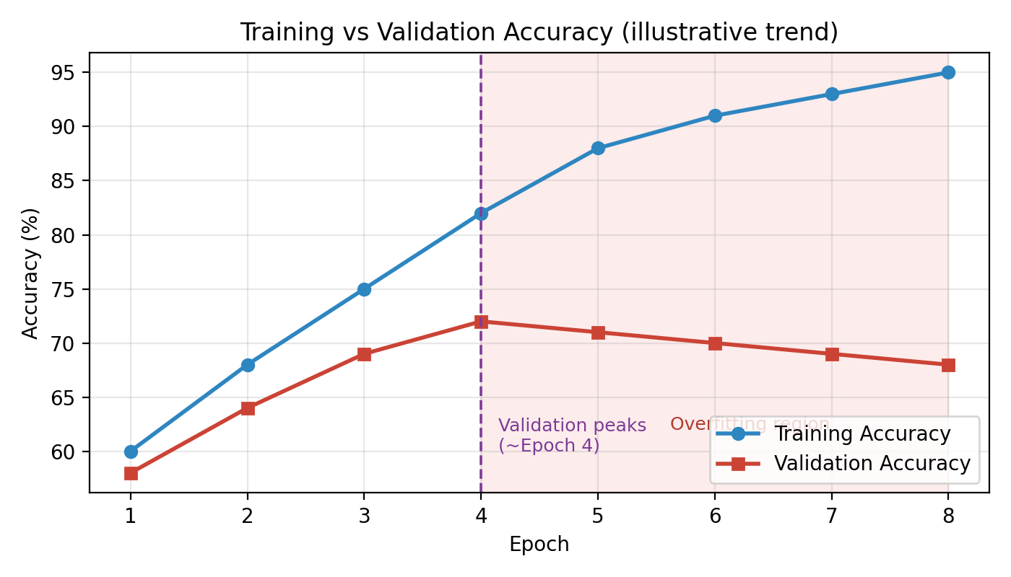

Issue Identified: Overfitting
The widening gap between an ever-improving training accuracy and a declining validation accuracy is the classic signature of overfitting. After the point where validation accuracy peaks (~72%), the model continues to improve on the training set but its performance on unseen (validation) data worsens.

Why This Happens
- As training continues, the model — especially if it has high capacity (many parameters/layers) — starts to memorise fine-grained, sample-specific patterns and noise in the training data rather than learning features that generalize.
- The optimizer keeps reducing training loss/improving training accuracy because it directly optimises on that data, but those very specific patterns do not hold on new, unseen validation samples, so validation performance degrades even as training performance keeps climbing.

Techniques to Address It
- Early Stopping: monitor validation accuracy/loss during training and stop (or restore the best checkpoint) once it stops improving — here, training should have been stopped around the epoch where validation accuracy peaked at 72%, rather than continuing to the point where it fell to 68%.
- Regularization (L1/L2 penalty) or Dropout: L1/L2 penalizes large weights to keep the model simpler, while Dropout randomly deactivates neurons during training — both discourage the network from over-relying on specific weights/neurons and force it to learn more generalizable representations.
- (Other valid options): data augmentation to enlarge and diversify the effective training set, or reducing model complexity (fewer layers/parameters) to match the model's capacity to the amount of available data.

Significance of Validation Accuracy
Validation accuracy is computed on data the model does not train on, so it gives an unbiased estimate of how well the model will generalize to new, real-world inputs — unlike training accuracy, which only reflects how well the model fits data it has already seen. It is the primary signal used for hyperparameter tuning, model/architecture selection, and deciding when to stop training (early stopping), making it essential for building a model that performs reliably beyond the training set rather than one that has simply memorised it.

